\\Gimecb01\homedir-eh$\heckler\Clipart\banking supervision\ECB_BS_EN_RGB.emf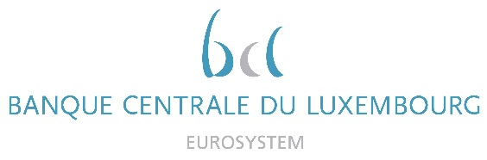

|  |  |
| --- | --- |
|  | Calendar of Eric Cadilhac  Head of SSM Coordination at Banque centrale du Luxembourg and Member of the Supervisory Board of the Single Supervisory Mechanism  January 2022 |

|  |  |  |
| --- | --- | --- |
| Date | Meeting / Event (incl. topic / meeting participants, as applicable) | Location |
| 17 January 2022 | Steering Committee of the Supervisory Board in Digital Agenda composition (via video conference) | Luxembourg |
| 28 January 2022 | Seminar of the Supervisory Board followed by an ad hoc meeting (via video conference) | Luxembourg |
|  |  |  |
|  |  |  |
|  |  |  |
|  |  |  |
|  |  |  |
|  |  |  |
|  |  |  |
|  |  |  |
|  |  |  |
|  |  |  |
|  |  |  |
|  |  |  |
|  |  |  |
|  |  |  |