\\Gimecb01\homedir-eh$\heckler\Clipart\banking supervision\ECB_BS_EN_RGB.emf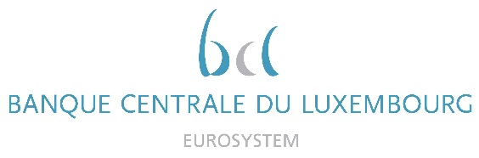

|  |  |
| --- | --- |
|  | Calendar of Eric Cadilhac  Head of SSM Coordination at Banque centrale du Luxembourg and Member of the Supervisory Board of the Single Supervisory Mechanism  February 2022 |

|  |  |  |
| --- | --- | --- |
| Date | Meeting / Event (incl. topic / meeting participants, as applicable) | Location |
| 02 February 2022 | Meeting of the Board of Directors (Conseil d’aministration) of AEDBF Luxembourg Asbl (via videoconference) | Luxembourg |
| 10 February 2022 | Joint meetings with the CSSF and ECB Senior Management (via videoconference) | Luxembourg |
| 17 February 2022 | Supervisory Board (via video conference) | Luxembourg |
| 22 February 2022 | Technical discussion with a software provider (via video conference) | Luxembourg |
| 23 February 2022 | Ad hoc Supervisory Board (via video conference) | Luxembourg |
| 24 February 2022 | Technical discussion with a IT services provider (via video conference) | Luxembourg |
| 27 February 2022 | Ad hoc meeting of the Supervisory Board (via video conference) | Luxembourg |
|  |  |  |
|  |  |  |
|  |  |  |
|  |  |  |
|  |  |  |
|  |  |  |
|  |  |  |
|  |  |  |
|  |  |  |
|  |  |  |