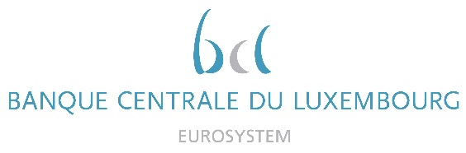

Calendar of Eric Cadilhac

Head of SSM Coordination at Banque centrale du Luxembourg and Member of the Supervisory Board of the Single Supervisory Mechanism
March 2021
Date | Meeting / Event (incl. topic / meeting participants, as applicable) | Location
03 March 2021 | Seminar of the Supervisory Board (via video conference) | Luxembourg
04 March 2021 | Steering Committee of the Supervisory Board (via video conference) | Luxembourg
10 March 2021 | Meeting with the IMF – Art. IV mission team (via video conference) | Luxembourg

