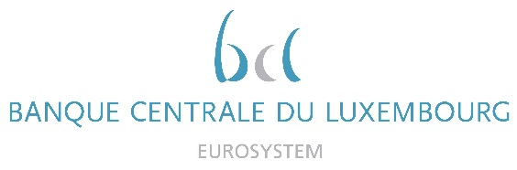

Calendar of Eric Cadilhac

Head of SSM Coordination at Banque centrale du Luxembourg and Member of the Supervisory Board of the Single Supervisory Mechanism
December 2021
Date | Meeting / Event (incl. topic / meeting participants, as applicable) | Location
01 December 2021 | Supervisory Board, continuation (via video conference) | Luxembourg
06 December 2021 | Steering Committee of the Supervisory Board for SSM integration and Simplification (via video conference) | Luxembourg
09/10 December 2021 | Attendance to the ECB Legal conference (virtual conference) | Luxembourg
13 December 2021 | Steering Committee of the Supervisory Board in Digital Agenda composition (via video conference) | Luxembourg
16 December 2021 | Attendance to the annual General Meeting and diner of the ALJB (Luxembourg Banking Lawyers Association) | Luxembourg
18 December 2021 | Steering Committee of the Supervisory Board (via video conference) | Luxembourg

