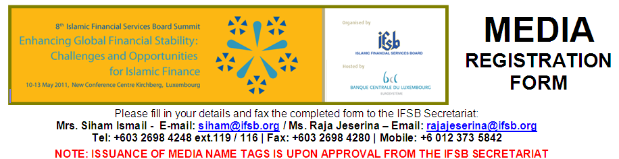
MEDIA CORRESPONDENT DETAILS
Name
Position |  |  |  | Department
Company
Address
Postcode |  | City |  |  | Country
Nationality |  | Email
Mobile |  | Tel |  |  | Fax
I WILL BE ATTENDING WITH: (please indicate “X” in the appropriate box)
 | Photographer | Number of Pax:
 | Camera Crew | Number of Pax:
 | Others (Editor etc) | Please Specify: |  |  | Number of Pax:
I WILL BE COVERING THE FOLLOWING EVENTS: (please indicate “X” in the appropriate box)
TUESDAY, 10 MAY 2011
 | Workshop on Islamic Finance and the IFSB Standards (open to all media)
WEDNESDAY, 11 MAY 2011
 | LUXEMBOURG Country Showcase (open to all media)
 | MALAYSIA Country Showcase (open to all media)
 | Special Session on Liquidity Management in the Islamic Financial Services Industry (open to all media)
THURSDAY, 12 MAY 2011
 | 8th IFSB SUMMIT – Opening and Keynote Session (open to all media)
 | 8th IFSB SUMMIT – Sessions 1 – 3 (for approved media only)
FRIDAY, 13 MAY 2011
 | 8th IFSB SUMMIT – Sessions 4 – 5 (for approved media only)
IMPORTANT
- Issuance of a Media Pass for Comprehensive Summit Coverage is at the discretion of the IFSB. Passes will only be issued upon written submission of form and approval by the IFSB Secretariat
- Notification of confirmation will be issued to the correspondent stated above. Passes may be collected from the IFSB Secretariat from 10th May at the Chamber of Commerce, Luxembourg
- Upon confirmation of the pass, the IFSB will not be responsible for:
  - Securing entry visa for media representatives. Please contact the relevant authorities in your home country for all matters regarding your visa requirements.
  - Transport and accommodation for media representatives.
Please send all registration forms via email/fax to the IFSB Secretariat on/before 21st April 2011.
( Email: siham@ifsb.org / rajajeserina@ifsb.org / Fax: + 603 2698 4280 )

