\\Gimecb01\homedir-eh$\heckler\Clipart\banking supervision\ECB_BS_EN_RGB.emf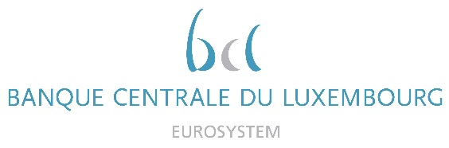

|  |  |
| --- | --- |
|  | Calendar of Eric Cadilhac  Head of SSM Coordination at Banque centrale du Luxembourg and Member of the Supervisory Board of the Single Supervisory Mechanism  March 2022 |

|  |  |  |
| --- | --- | --- |
| Date | Meeting / Event (incl. topic / meeting participants, as applicable) | Location |
| 01 March 2022 | Meeting with the IMF on Article IV consultation (via video conference) | Luxembourg |
| 04 March 2022 | Ad hoc meeting of the Supervisory Board meeting (via video conference) | Luxembourg |
| 07 March 2022 | Technical meeting with a Software and IT services providers (via video conference) | Luxembourg |
| 10 March 2022 | Meeting with the IMF, the ECB and the CSSF in the context of the Article IV consultation (via video conference) | Luxembourg |
| 10 March 2022 | Steering Committee of the Supervisory Board (via video conference) | Luxembourg |
| 17 March 2022 | Supervisory Board (via video conference) | Luxembourg |
| 18 March 2022 | Supervisory Board, continued (via video conference) | Luxembourg |
| 21 March 2022 | Ad hoc meeting of the Supervisory Board (via video conference) | Luxembourg |
| 22 March 2022 | Technical discussion with an IT services provider (via video conference) | Luxembourg |
| 22 March 2022 | Attendance to the conference organised by The Bridge Forum Dialogue on "The Future of the European Union" with Mr Pierre Moscovici as keynote speaker (hybrid event) | Luxembourg |
|  |  |  |
|  |  |  |
|  |  |  |
|  |  |  |
|  |  |  |
|  |  |  |