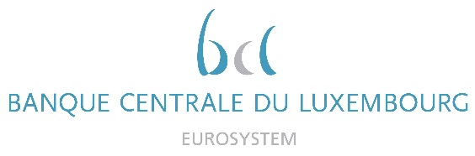

Calendar of Eric Cadilhac

Head of SSM Coordination at Banque centrale du Luxembourg and Member of the Supervisory Board of the Single Supervisory Mechanism
April 2021
Date | Meeting / Event (incl. topic / meeting participants, as applicable) | Location
16 April 2021 | Steering Committee of the Supervisory Board in simplification agenda composition (via video conference) | Luxembourg
19 April 2021 | Board (Conseil d’administration) meeting of the AEDBF Luxembourg Asbl | Luxembourg
22 April 2021 | Supervisory Board (via video conference) | Luxembourg
22 April 2021 | Supervisory Board, continuation (via video conference) | Luxembourg
28 April 2021 | Meeting with a NewTech company for a live demonstration of a Natural Language Processing product (via video conference) | Luxembourg

