\\Gimecb01\homedir-eh$\heckler\Clipart\banking supervision\ECB_BS_EN_RGB.emf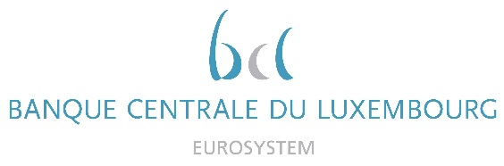

|  |  |
| --- | --- |
|  | Calendar of Eric Cadilhac  Head of SSM Coordination at Banque centrale du Luxembourg and Member of the Supervisory Board of the Single Supervisory Mechanism  April 2022 |

|  |  |  |
| --- | --- | --- |
| Date | Meeting / Event (incl. topic / meeting participants, as applicable) | Location |
| 06 April 2022 | Attending the joint conference of the ECB and the European Commission on the Financial Sector (via videoconference) | Luxembourg |
| 11 April 2022 | Board meeting of AEDBF Luxembourg Asbl (via videoconference) | Luxembourg |
| 28 April 2022 | Supervisory Board (via videoconference) | Luxembourg |
| 29 April 2022 | Supervisory Board, continued (via videoconference) | Luxembourg |
|  |  |  |
|  |  |  |
|  |  |  |
|  |  |  |
|  |  |  |
|  |  |  |
|  |  |  |
|  |  |  |
|  |  |  |
|  |  |  |
|  |  |  |
|  |  |  |