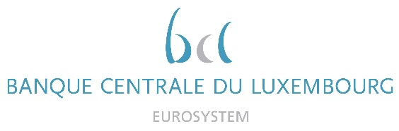

Calendar of Eric Cadilhac

Head of SSM Coordination at Banque centrale du Luxembourg and Member of the Supervisory Board of the Single Supervisory Mechanism
May 2021
Date | Meeting / Event (incl. topic / meeting participants, as applicable) | Location
3 May 2021 | Steering Committee of the Supervisory Board in Digital Agenda composition (via video conference) | Luxembourg
5 May 2021 | Supervisory Board seminar (via video conference) | Luxembourg
6 May 2021 | Steering Committee of the Supervisory Board (via video conference) | Luxembourg
7 May 2021 | Call with an external consultant on Automated Text Processing solutions (via video conference) | Luxembourg
14 May 2021 | Call with an external consultant on Robotic Process Automation solutions (via video conference) | Luxembourg
18 May 2021 | Attendance at the Bridge Forum Dialogue conference on China (via video conference) | Luxembourg
21 May 2021 | Attendance at the 13th SSM Round Table organised by the International Bankers Forum (via video conference) | Luxembourg
27 May 2021 | Attendance at the Annual joint European Commission and ECB conference on the European and Financial Integration and Stability (via video conference) | Luxembourg
27 May 2021 | Attendance at the ECB legal colloquium on climate change litigation (via video conference) | Luxembourg

