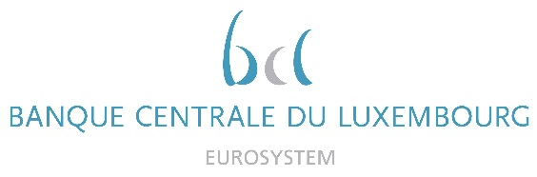

Calendar of Eric Cadilhac

Head of SSM Coordination at Banque centrale du Luxembourg and Member of the Supervisory Board of the Single Supervisory Mechanism
June 2021
Date | Meeting / Event (incl. topic / meeting participants, as applicable) | Location
7 June 2021 | Steering Committee of the Supervisory Board in Digital agenda composition (via video conference) | Luxembourg
9 June 2021 | Attendance at an EPCO European Procurement Experts meeting on pre-commercial procurement framework for innovations with the European Commission (via video conference) | Luxembourg
10 June 2021 | Attendance at the Bridge Forum Dialogue on the ITER project (via video conference) | Luxembourg
16 June 2021 | Steering Committee of the Supervisory Board in Simplification agenda composition (via video conference) | Luxembourg
22 June 2021 | Supervisory Board (via video conference) | Luxembourg
23 June 2021 | Supervisory Board, continuation (via video conference) | Luxembourg
23 June 2021 | Macroprudential Forum (via video conference) | Luxembourg
24 June 2021 | Calls (separately) with two consultancy firms in the area of Robotic Process Automation (via video conference) | Luxembourg

