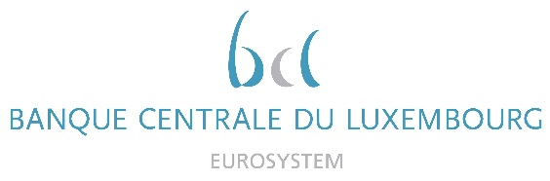

Calendar of Eric Cadilhac

Head of SSM Coordination at Banque centrale du Luxembourg and Member of the Supervisory Board of the Single Supervisory Mechanism
November 2021
Date | Meeting / Event (incl. topic / meeting participants, as applicable) | Location
05 November 2021 | Supervisory Board (via video conference) | Luxembourg
08 November 2021 | Steering Committee of the Supervisory Board in Digital Agenda composition (via video conference) | Luxembourg
09/10 November 2021 | Attendance to the ECB Banking Forum (virtual conference) | Luxembourg
11 November 2021 | Attendance to the 14th SSM round table organised by the International Bankers Forum (IBF) and the Central Bank of Ireland (virtual conference) | Luxembourg
15 November 2021 | Seminar of the Supervisory Board (via video conference) | Luxembourg
18 November 2021 | Steering Committee of the Supervisory Board – Close cooperation review (via video conference) | Luxembourg
24 November 2021 | Meeting of the SSM Informal Contact Group of Parliamentary Affairs (via video conference) | Luxembourg
24 November 2021 | Macroprudential Forum of the Governing Council and the Supervisory Board | Luxembourg
25 November 2021 | Diner with the Chair of the Supervisory Board and members of the Executive Boards of the CSSF and BCL | Luxembourg
26 November 2021 | Meeting with representatives of the ABBL (Luxembourg Banks and Bankers Association) in the context of the country visit of the Chair of the Supervisory Board (via video conference) | Luxembourg
30 November 2021 | Supervisory Board (via video conference) | Luxembourg

